# Flowchart and Wireframes

### Robin Flynn Website Notes, Wireframes and Flowchart by Eric

## 

## Disclaimer

Please ***do not*** ***put any personal or sensitive information*** on this document (*e.g. phone numbers, credit cards, addresses, etc.*). This document is accessible to several persons beyond the client and developer and the information presented henceforth will be regarded as non-sensitive material. In general, unencrypted documents such as these should ***not*** be used to store personal or sensitive information.

## Purpose

Welcome, Robin! This document exists to gather information necessary to developing a website for you, the client. Please provide links to ***three websites*** that you like with a bulleted list explaining why, so that I may better serve your needs. Below I will provide examples of websites that I believe may serve similar purposes to yours along with my reasoning provided in the form of bulleted notes.

## Example Websites

* Example 1: <https://cosmicspectrum.art/>
  + Simple, clean design
    - ***Keeps focus on displaying art***
  + Straightforward and easy to navigate
* Example 2: <https://www.zoekeller.com/>
  + Detailed website with a plethora of information
  + About page includes bio, artist statement, education, exhibitions, etc.
    - Information important to employers
  + Has pages with detailed information regarding ***commissions for individuals and businesses***
* Example 3: [https://www.jasmindarnell.com/](https://www.jasmindarnell.com/gallery)
  + Simple layout with essentials
    - ***Gallery of completed works***
    - Simple about page

## Flowchart diagram

Below is a flowchart charting proposed web pages along with their relationships and navigation.

#### 

# Wireframes

Below are wireframes to represent proposed web page designs across various device layouts.

## Phone (main page)

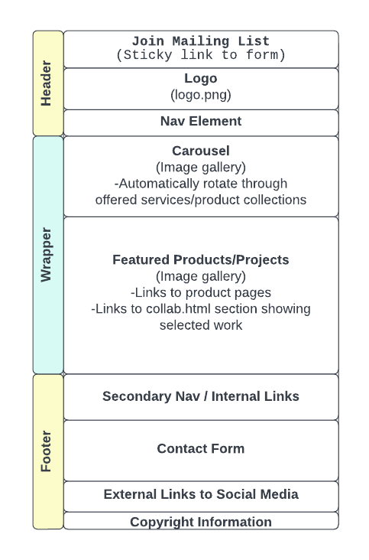

## **Desktop/Tablet (main page**)

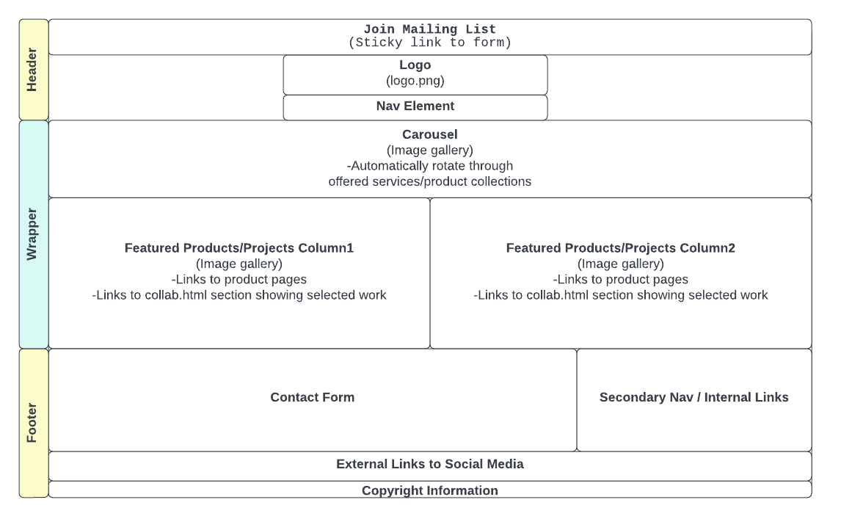

## Phone (secondary page)

## 

## Desktop/Tablet (secondary page)

#### 